# C# Programming - Class 2

**Module 06 Assignment: Data Driven Applications**



**Step 1: Research**

In this module you will continue to learn more about creating C# applications using the Entity Framework.

1. Please review the following web pages:

Lesson 06: Adding Parameters to Commands

<http://www.csharp-station.com/tutorials/adodotnet/lesson06.aspx>

Lesson 07: Using Stored Procedures

<http://www.csharp-station.com/tutorials/adodotnet/lesson07.aspx>

The ADO.NET command parameters

<http://dotnetfacts.blogspot.com/2009/01/adonet-command-parameters.html>

Modifying Data with Stored Procedures (ADO.NET)

<http://msdn.microsoft.com/en-us/library/59x02y99.aspx>

LINQ to Entities

<http://www.tutorialspoint.com/linq/linq_entities.htm>

1. Please watch the following videos:

1_StoredProcedures.wmv

2_StoredProcedureParameters.wmv

3_WorkingWithStoredProcedures.wmv

**Step 2: Applying your knowledge**

In this Module, you need to create a data driven application using C#. Your instructor will provide you with the database, table, and SQL stored procedures. Your task will be to create a C# application that uses them.

**Project 1:** Write a program that displays, inserts, updates, and deletes data within a SQL table.

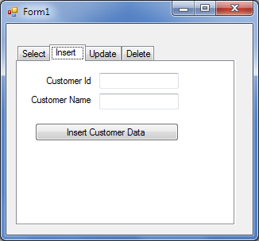

**Todo:**

1) Run the SQL code provided by your instructor by opening the HandsOnActivitySQLCode.sql file in SQL Management Studio and executing the code.

2) Create a UI similar to the one pictured above.

3) Working on one tab at a time, connect each tab to the four different stored procedures create by the instructors SQL code.

**Step 3: Submitting your work.**

Now save your work and copy the entire folder where the web application is to a USB drive or zip the folder and email the file to yourself. Either way, bring the folder with you to class with you. Your teacher will create a similar program that you can use to compare your solution to.